**Unit 6 Programming Project 1**

Solve the following programming problems. For each problem, you should create an algorithm either in pseudocode or as a flowchart, implement the program in Java, and then compile and execute the Java program on [Browxy.com](http://browxy.com/). Browxy.com is very intuitive. Please see the screenshot below to understand how to use the online programming environment.

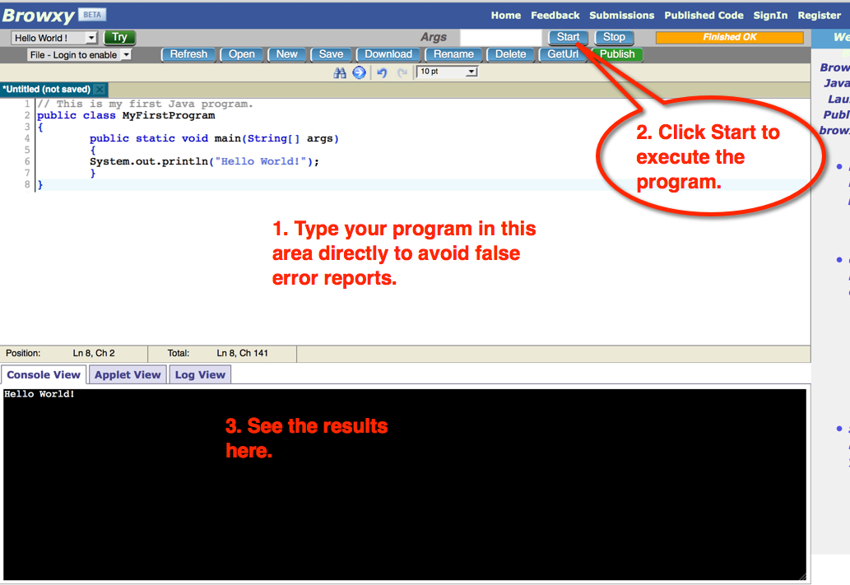

For each of the four problems, you should submit the following,

* an algorithm.
* a Java program.
* a screenshot that includes your Java program and the *Console View* box. Please see the screenshot above to understand what your screenshots should look like.

# Problem 1

Your First Java Program for this assignment will help you get acquainted with the free online programming environment, [Browxy.com](http://browxy.com/). **Please note you may want to type your programs on Browxy.com directly to avoid false error reports. Don’t copy any program from a Word document and paste it on Browxy.com. Word will add extra invisible codes to the program and you will receive false error reports when you compile and execute the program on Browxy.com.**

Here is the Java program you will enter:

*// This is my first Java program.*

*public class MyFirstProgram*

*{*

*public static void main( String[] args)*

*{*

*System. out. println(“ Hello World!”);*

*}*

*}*

## Algorithm for Problem 1

## Java Program (*The Java program has been provided to you.*)

// This is my first Java program.

public class MyFirstProgram

{

    public static void main(String[] args)

    {

        System.out.println("Hello World!");

    }

}

## Screenshot of the result on Browxy.com

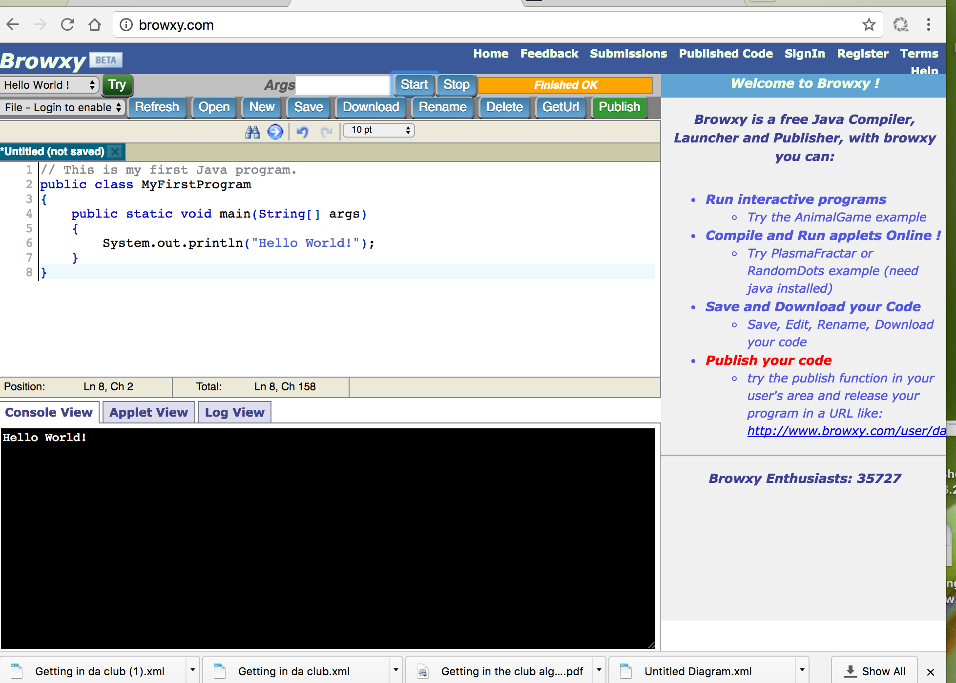

# Problem 2

Write an application that displays your initials in large block letters. Make each large letter out of the corresponding regular character. For example:

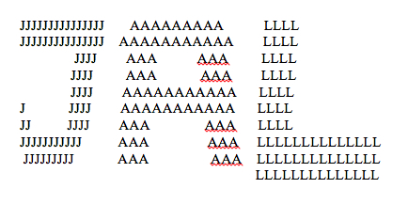

## Algorithm for Problem 2

## Java Program

## Screenshot of the result on Browxy.com

# Program 3

Write a program that prints an imitation of the Composition II in Red, Blue, and Yellow created in 1930 by Piet Mondrian painting, illustrated below.

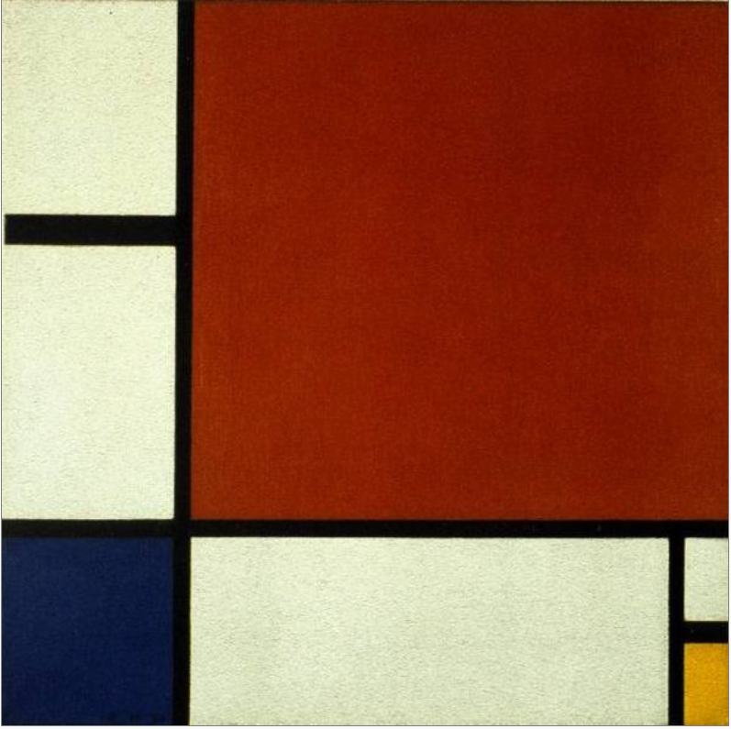

Use character sequences such as @@@ or ::: to indicate different colors and use – and | to form the black lines.

## Algorithm for Problem 3

## Java Program

## Screenshot of the result on Browxy.com

# Program 4

In the United States there is no federal sales tax, so every state may impose its own sales taxes. Look on the Internet for sales tax charged in five US states, then write a program that prints the tax rates for five states of your choice. For example,

Sales Tax Rates

----------------------

Alaska: 0%

Hawaii: 4%

## Algorithm for Problem 4

## Java Program

## Screenshot of the result on Browxy.com